MS Excel is a “real-life” application of analytical technique and they are without a doubt the most sought-after analytical tool available due to its built-in pivot tables. An analyst can simply import, browse, clean, analyze, and visualize the data using this all-in-one data management tool. In addition, the data analysis tool pack and pivot table simply analyze the dataset and provides high-level visual summaries, trends, and patterns. In this way, MS excel helps in analysis.

The data set “US Crime” is used in the analysis. The dataset consists of 3,06,094 observations and 30 variables which include categorical as well as numerical. Based on the number of observations, we can say that there are 3,060,94 US crime counts in the data set.

There are 14 numerical variables and 16 categorical variables (see full list below).

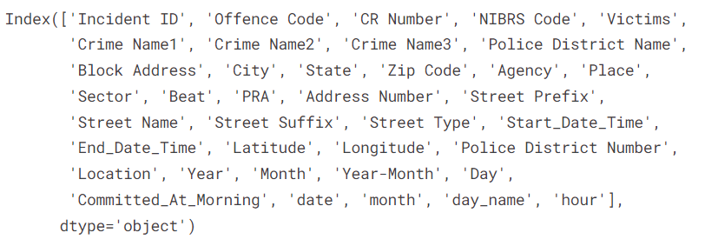

In addition, the dataset includes NaN or missing values which can be filled with the help of statistics concept or central tendency.

After observing the data set, we could say that there is no target value or dependent variable, but it doesn’t mean we can not visualize. We can visualize the dataset without the target value. So, our next step is to visualize the Crime data set through a pivot table in MS Excel.

The above chart shows the total number of victims did crimes against persons, property, etc. The highest number of victims cases police were reported against property i.e., 1,39,882, and the second highest number of cases were reported against society i.e., 68,917. Thus, the United States has the most victims in property crime cases.

The above charts display the top 10 victims in the US city. In the US, Silver Spring city reported the highest number of victim cases, and the second highest number of victim cases were reported in the Gaithersburg City of US. Thus, if any person wants to buy a house and plan for a location, then this visualization of the victims’ reports gives better insights and helps in decision-making.

This is the top 10 list of agency or department of police that reports the total number of victims in the police department. So, we easily conclude that the highest number of victims were reported in Montgomery County Police Department in the U.S.

It displays the total number of crime cases reported in the US. As we see that the criminal cases against property are the highest as compared to the other criminal cases.

Finally, the reported effectiveness of the system for experts of various skill levels who want to investigate and visualise datasets, it is a flexible, strong tool. Here are some examples of the different kinds of data visualisations you may make in Excel, along with the processes necessary to do so and some advice to guide you. Also, it helps in decision making.

# **References**

Analytics Vidhya. 2019. A Comprehensive guide to Microsoft Excel for Data Analysis. [online] Available at: <https://www.analyticsvidhya.com/blog/2021/11/a-comprehensive-guide-on-microsoft-excel-for-data-analysis/> [Accessed 24 April 2019]

Carlberg, C. (2013). *Decision Analytics: Microsoft Excel*. Que Publishing. Retrieved from <https://books.google.com/books?hl=en&lr=&id=jcvYAQAAQBAJ&oi=fnd&pg=PR3&dq=excel+analytics+techniques&ots=HM1ej_HkYT&sig=kdMKnGYMs4bKGnUnrUOH-yoQnIg>.

Turner, G. F., & Bennett, D. J. The Benefits of Using Excel-Based Homework That Grades Itself. Retrieved from http://web.simmons.edu/~turnerg/APS2008/APS2008.pdf